## Advance Web Technology

**React-app**



**Project Supervisor: Sir Safiullah**

**Submitted By:**

Maryam Shehzadi 20006105016

BS-IT BATCH 6

## Session

## (2020-2024)

## University of Management and Technology

## Sialkot, Pakistan

**Question: 01**

**React To-Do List Challenge: Boost Your Productivity!**

**Objective:**

**Build a single-page to-do list application using React.js. This application should offer**

**features to manage your daily tasks effectively.**

**Functionality:**

**Task Management:**

* **Users can enter new tasks using an input field.**
* **New tasks are added to the to-do list on submission.**
* **Existing tasks can be marked as completed by clicking a checkbox beside**
* **them.**
* **Users should be able to delete unwanted tasks from the list.**

**Persistence:**

* **Utilize local storage to save the current state of the to-do list (including**
* **tasks and their completion status) even after the browser is refreshed.**
* **When the application loads, retrieve the saved data from local storage and**
* **populate the list accordingly.**

**Technical Specifications:**

* **Use React.js to build the user interface and manage component state.**
* **Employ JavaScript for handling user interactions and logic.**
* **Consider using CSS for basic styling of the application.**
* **Bonus Features (Optional):**
* **Implement a &quot;clear completed&quot; button to remove all completed tasks from the list**
* **at once.**

**Allow users to edit existing tasks by double-clicking or providing an edit**

**functionality.**

* **Categorize tasks by priority levels (high, medium, low).**
* **Enhance user experience with animations or visual feedback for actions like**
* **adding, deleting, or marking tasks complete.**

**Evaluation Criteria:**

* **Functionality: (70%) Does the application fulfill all the core requirements**
* **(adding, marking complete, deleting tasks) and persist data using local storage?**
* **Code Quality: (20%) Is the code well-structured, readable, and commented?**
* **User Interface: (10%) Does the application have a clean and user-friendly**
* **interface? (Bonus points for extra features)**

**Hints:**

* **Take advantage of React&#39;s state management features like useState to track the**
* **list of tasks and their completion status.**
* **Explore using local storage APIs to save and retrieve data.**
* **Consider using libraries like classnames for conditional styling based on task**
* **completion.**

**Ans:**

**Set Up Your Development Environment:**

* Ensure you have Node.js and npm installed.
* Create a new React application using Create React App



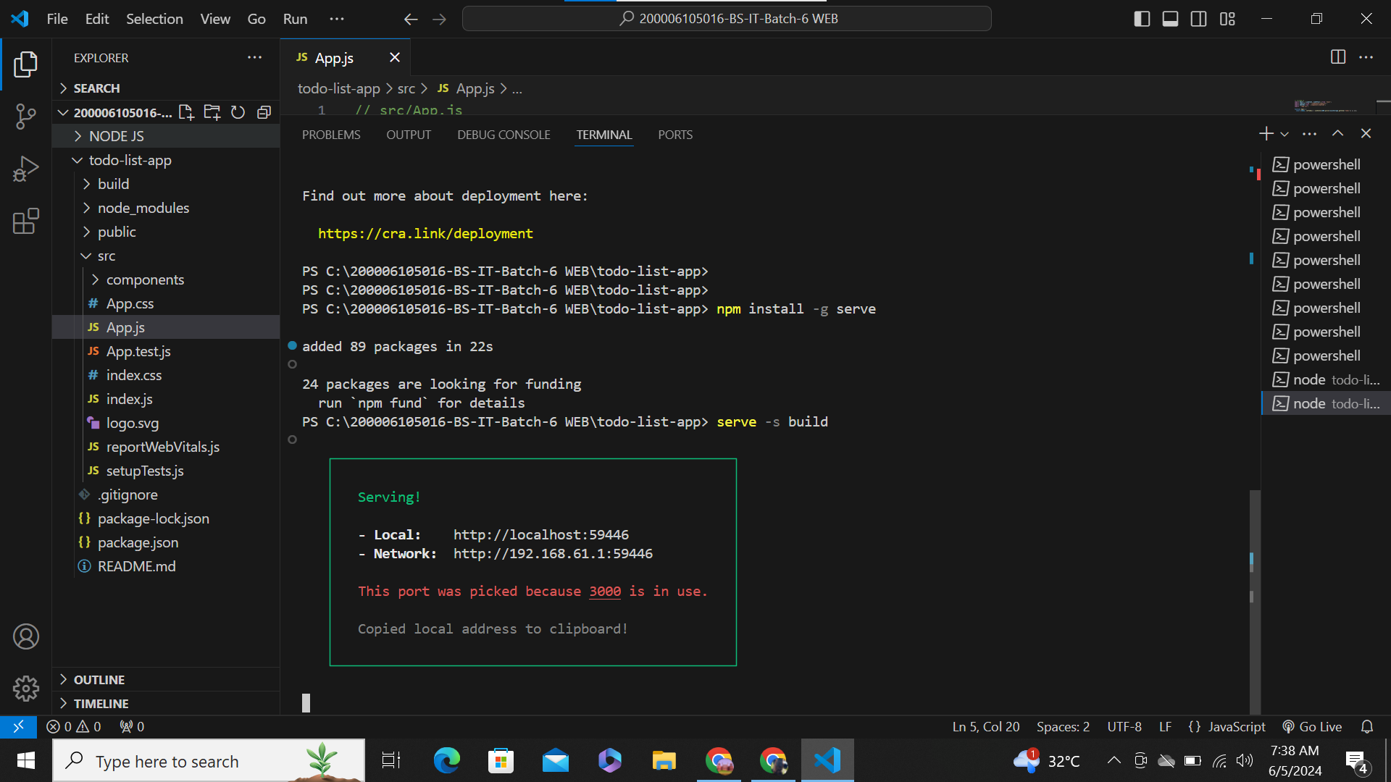

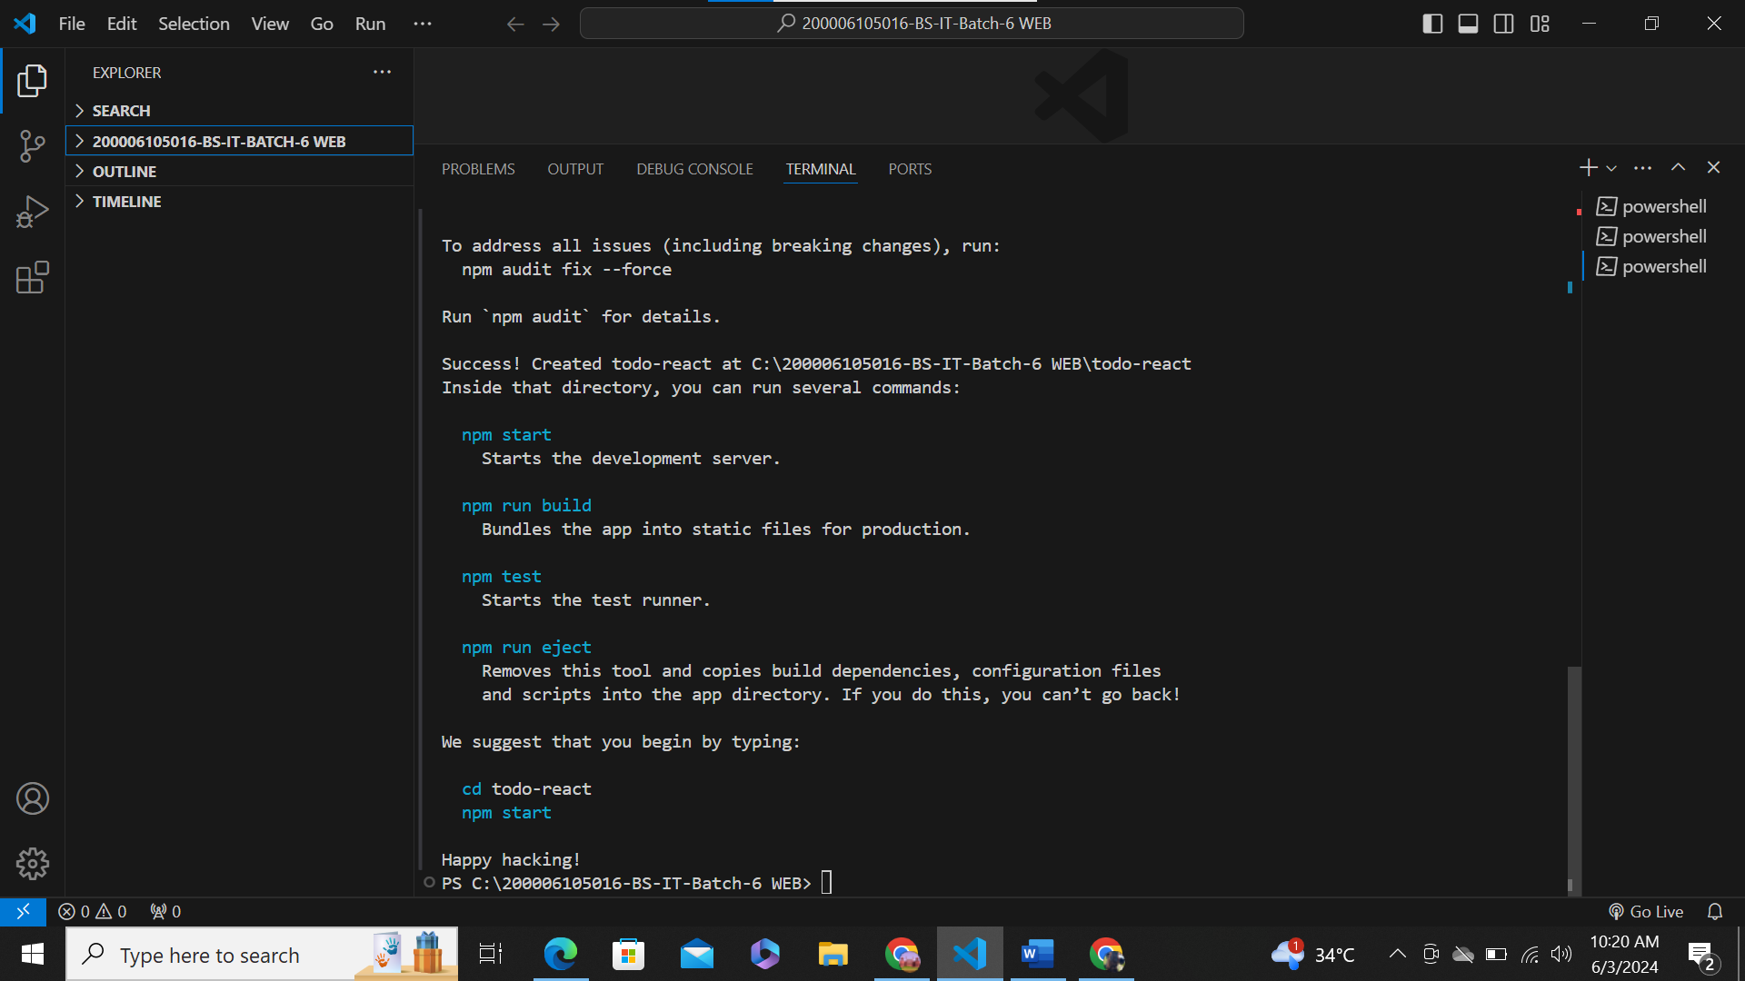

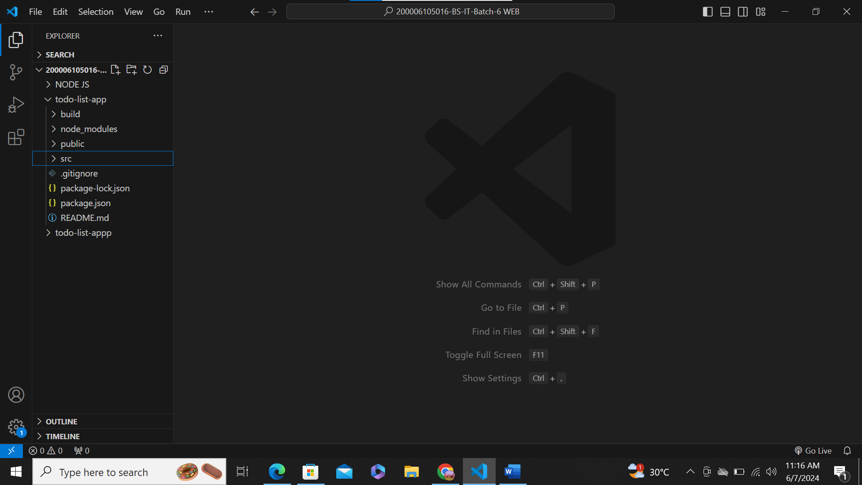

React Folder Name

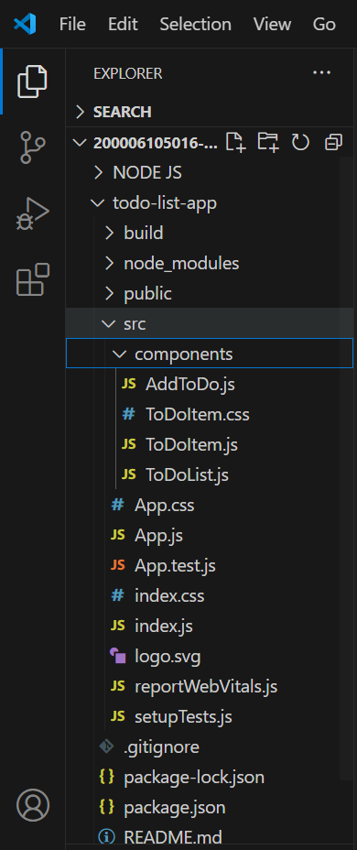

**Create the To-Do List Component:**

* In the ***src*** directory, create a new file called TodoList.js.

**Functionality:**

* **Add Task:** Adds a new task to the list.
* **Toggle Task Completion:** Toggles the completion status of a task.
* **Delete Task:** Deletes a task from the list**.**

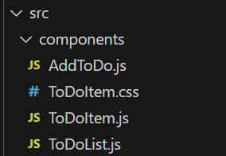

* **AddtoDo.js File:**

// src/components/AddToDo.js

import React, { useState } from 'react';

function AddToDo({ addTask }) {

    const [value, setValue] = useState('');

    const handleSubmit = (e) => {

        e.preventDefault();

        if (!value.trim()) return;  // Prevent adding empty tasks

        addTask(value);

        setValue('');  // Clear input field after submission

    };

    return (

        <form onSubmit={handleSubmit} className="task-form">

            <input

                type="text"

                className="task-input"

                value={value}

                onChange={(e) => setValue(e.target.value)}

                placeholder="Enter a new task"

            />

            <button type="submit" className="task-button">Add Task</button>

        </form>

    );

}

export default AddToDo;

* **ToDoItem.css File:**

/* ToDoItem.css */

.edit-button, .delete-button {

    margin-left: 10px;

    padding: 5px 10px;

    border: none;

    border-radius: 4px;

    cursor: pointer;

    outline: none;

  }

  .edit-button {

    background-color: #4CAF50; /* Green */

    color: white;

  }

  .delete-button {

    background-color: #f44336; /* Red */

    color: white;

  }

  .task-input {

    margin-right: 10px;

    padding: 5px;

    border: 2px solid #ddd;

    border-radius: 4px;

  }

* **ToDoItem.js File:**

import React, { useState } from 'react';

function ToDoItem({ item, toggleTask, deleteTask, editTask }) {

  const [isEditing, setIsEditing] = useState(false);

  const [editText, setEditText] = useState(item.task);

  const handleEditChange = (e) => {

    setEditText(e.target.value);

  };

  const handleToggleEdit = () => {

    if (isEditing) {

      editTask(item.id, editText); // Call the editTask function passed from parent

      setIsEditing(false); // Exit editing mode

    } else {

      setIsEditing(true); // Enter editing mode

      setEditText(item.task); // Initialize the text input with the current task

    }

  };

  return (

    <div className="task-item" style={{ marginBottom: "10px" }}>

      <input

        type="checkbox"

        checked={item.completed}

        onChange={() => toggleTask(item.id)}

        className="checkbox"

      />

      {isEditing ? (

        <input

          type="text"

          value={editText}

          onChange={handleEditChange}

          className="task-input"

          style={{ marginLeft: '10px' }}

        />

      ) : (

        <span style={{ textDecoration: item.completed ? 'line-through' : 'none', marginLeft: '10px' }}>

          {item.task}

        </span>

      )}

      {isEditing ? (

        <button onClick={handleToggleEdit} style={{ marginLeft: '10px' }}>

          Save

        </button>

      ) : (

        <>

          <button onClick={handleToggleEdit} style={{ marginLeft: '10px', color: 'Blue' , backgroundColor: 'light-pink'}}>

            Edit

          </button>

          <button onClick={() => deleteTask(item.id)} style={{ marginLeft: '10px' , color: 'red' }}>

            Delete

          </button>

        </>

      )}

    </div>

  );

}

export default ToDoItem;

* **ToDoList.js File:**

import React, { useState } from 'react';

import ToDoItem from './ToDoItem';

function ToDoList() {

  const [items, setItems] = useState([

    { id: 1, task: 'First Task', completed: false },

    { id: 2, task: 'Second Task', completed: false },

    { id: 3, task: 'Third Task', completed: false },

  ]);

  const toggleTask = (id) => {

    setItems(prevItems =>

      prevItems.map(item =>

        item.id === id ? { ...item, completed: !item.completed } : item

      )

    );

  };

  const deleteTask = (id) => {

    setItems(prevItems => prevItems.filter(item => item.id !== id));

  };

  return (

    <div>

      {items.map(item => (

        <ToDoItem key={item.id} item={item} toggleTask={toggleTask} deleteTask={deleteTask} />

      ))}

    </div>

  );

}

export default ToDoList;

**src App.js**

**Main Component:** App.js serves as the main component of the React application, defining its overall structure and layout.

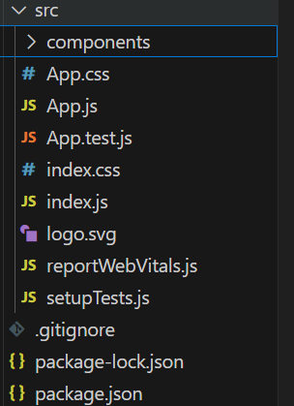

* **App.js File:**

// src/App.js

import React, { useState, useEffect } from 'react';

import ToDoList from './components/ToDoList';

import AddToDo from './components/AddToDo';

import './App.css';

function App() {

    const [toDos, setToDos] = useState([]);

    useEffect(() => {

        const storedToDos = JSON.parse(localStorage.getItem('todos'));

        if (storedToDos) {

            setToDos(storedToDos);

        }

    }, []);

    useEffect(() => {

        localStorage.setItem('todos', JSON.stringify(toDos));

    }, [toDos]);

    const addTask = (task) => {

        const newTask = { id: Date.now(), task, completed: false };

        setToDos([...toDos, newTask]);

    };

    const clearList = () => {

        setToDos([]);

    };

    return (

        <div className="app">

            <h1>To-Do List</h1>

            <AddToDo addTask={addTask} />

            <ToDoList items={toDos} />

            <button onClick={clearList} className="clear-list-button">Clear List</button>

        </div>

    );

}

export default App;

* **App.css File:**

/* src/App.css */

body {

  font-family: 'Arial', sans-serif;

  background-color: #f7f7f7;

  margin: 0;

  padding: 20px;

  display: flex;

  justify-content: center;

  align-items: center;

  height: 100vh;

}

.app {

  width: 100%;

  max-width: 360px;

  background: #fff;

  padding: 20px;

  border-radius: 8px;

  box-shadow: 0 4px 8px rgba(0,0,0,0.1);

}

h1 {

  color: #333;

  text-align: center;

}

/* src/App.css */

.clear-list-button {

  margin-top: 20px;

  padding: 10px 20px;

  background-color: #d6589f; /* Tomato red, change as needed */

  color: white;

  border: none;

  border-radius: 4px;

  cursor: pointer;

  width: 100%;

}

.clear-list-button:hover {

  background-color: #e55345; /* Darker shade for hover effect */

}

.task-input, .task-button {

  width: 100%;

  padding: 10px;

  margin: 5px 0;

  box-sizing: border-box;

}

.task-button {

  background-color: #2980b9;

  color: white;

  border: none;

}

.task-item {

  display: flex;

  align-items: center;

  justify-content: space-between; /* This will push the delete button to the right */

}

.delete-button {

  color: rgb(234, 23, 62); /* Text color */

  background-color: rgb(196, 94, 94); /* Background color */

  border: none; /* Optional: removes the border */

  padding: 5px 10px; /* Padding around the text */

  cursor: pointer; /* Changes the cursor to a pointer on hover */

}

.task-text {

  flex-grow: 1; /* Allows the task text to take up any extra space, pushing the button right */

}

.task-form {

  margin-bottom: 20px;

}

**Change Directory:** The primary purpose of cd is to navigate through the directory structure of the file system. You can move from one directory to another using this command.

* **npm start** is a command used in Node.js/npm projects to start the application. When you run **npm** start in a Node.js project that has been set up to use this command, npm will look for a script called **"start"** in the "**scripts"** section of the **package.Json** file and execute it.

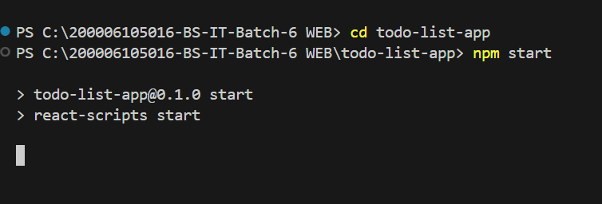

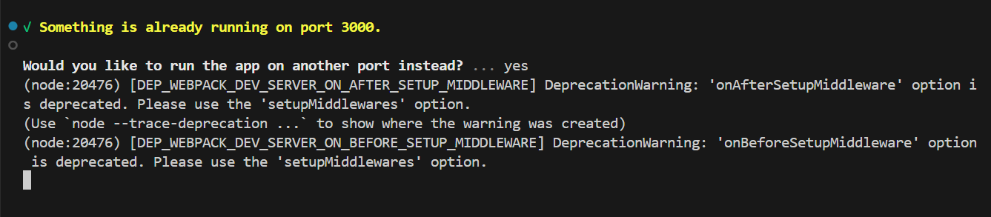

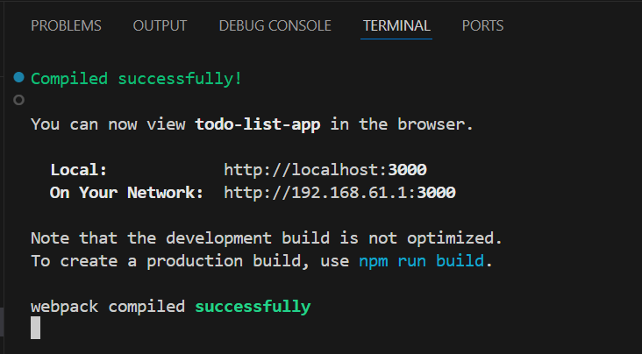

**Todo List Output:**

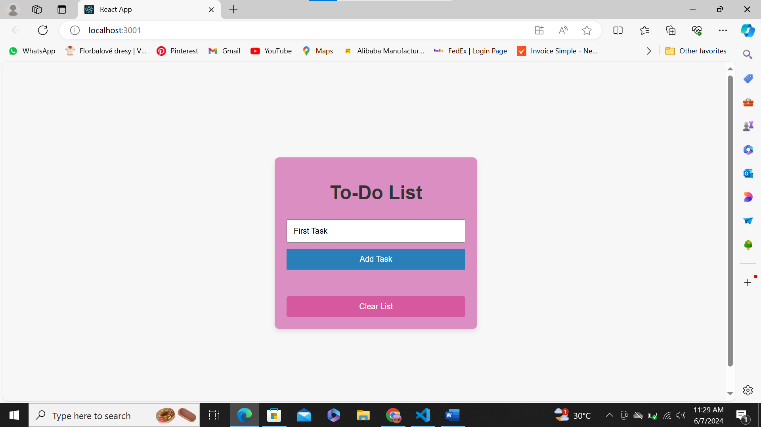

Add First Task

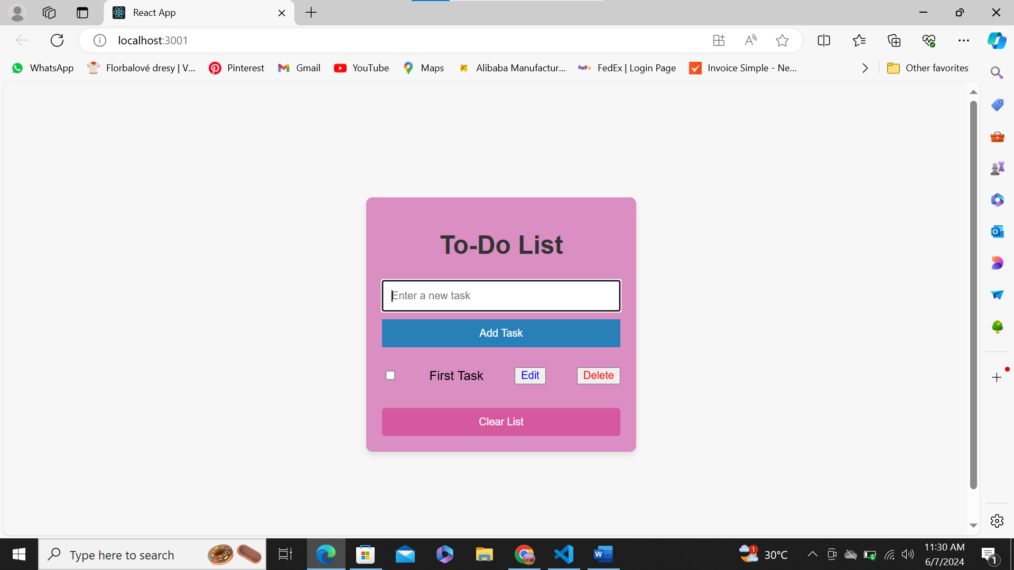

Task Added. Adding "Delete”, “Checkbox" and "Edit" buttons to a to-do list provides users with more control and flexibility over their tasks.

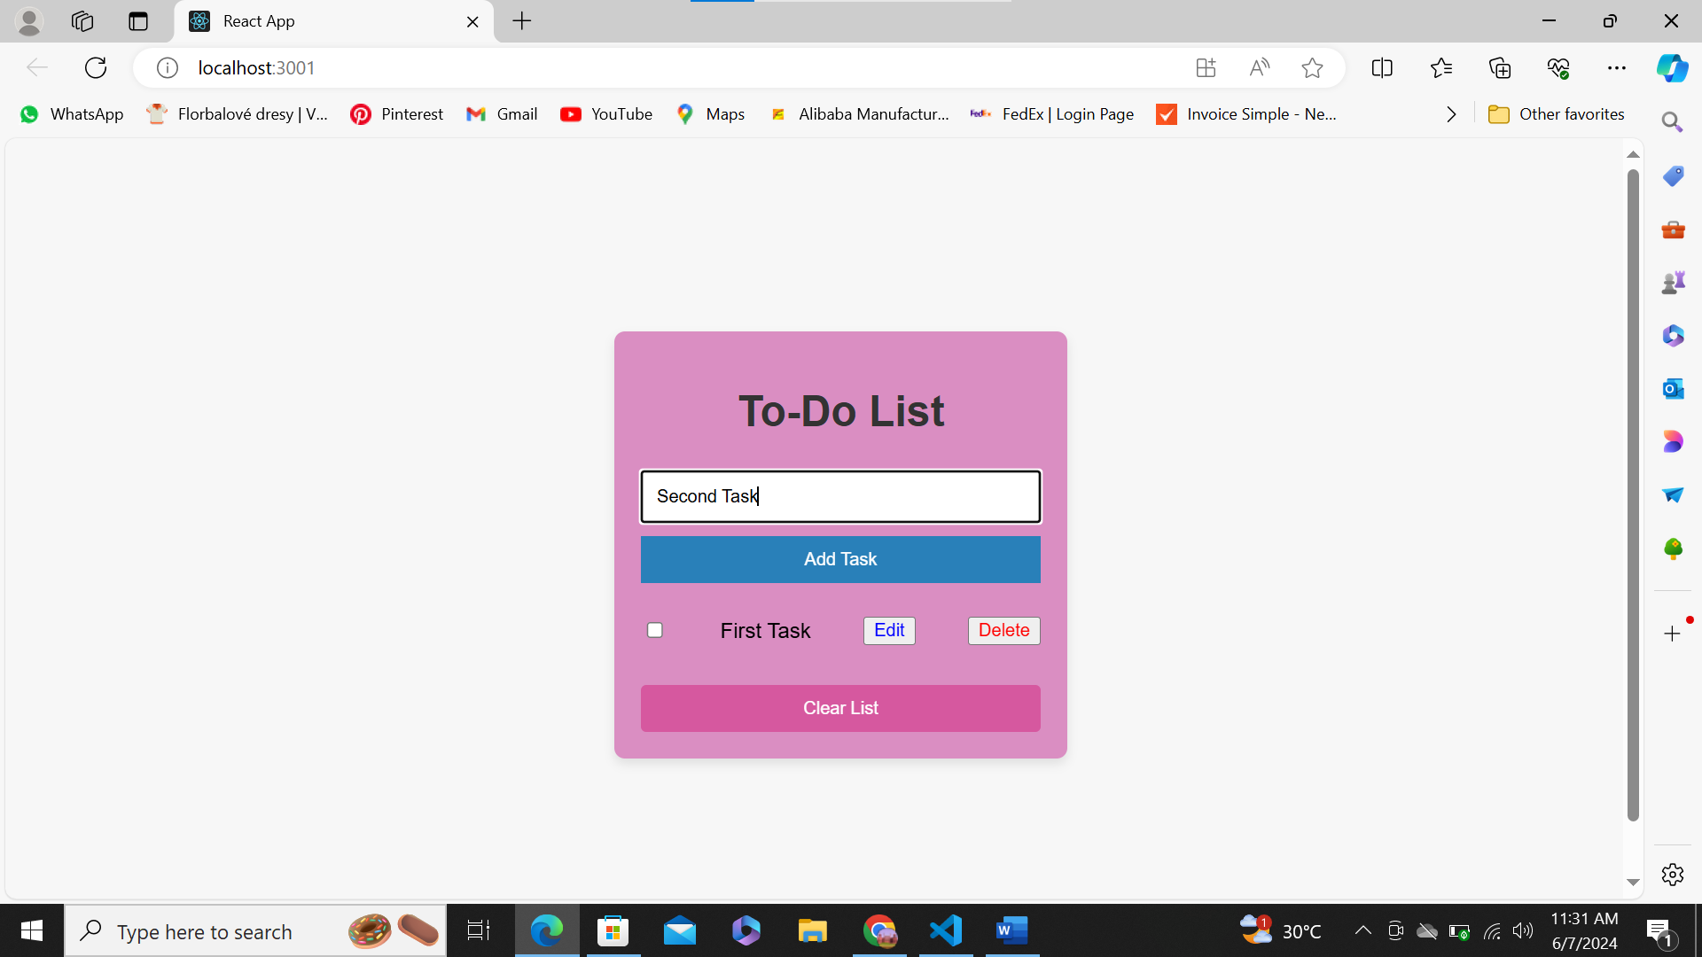

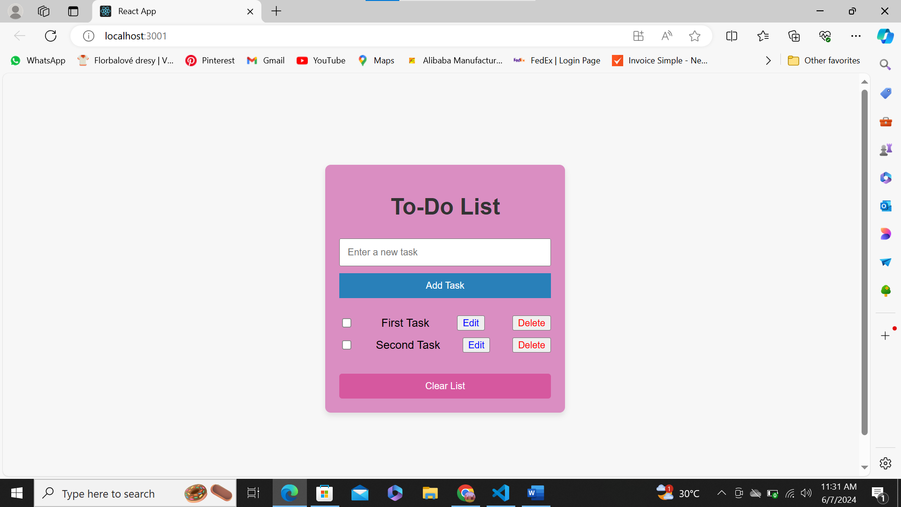

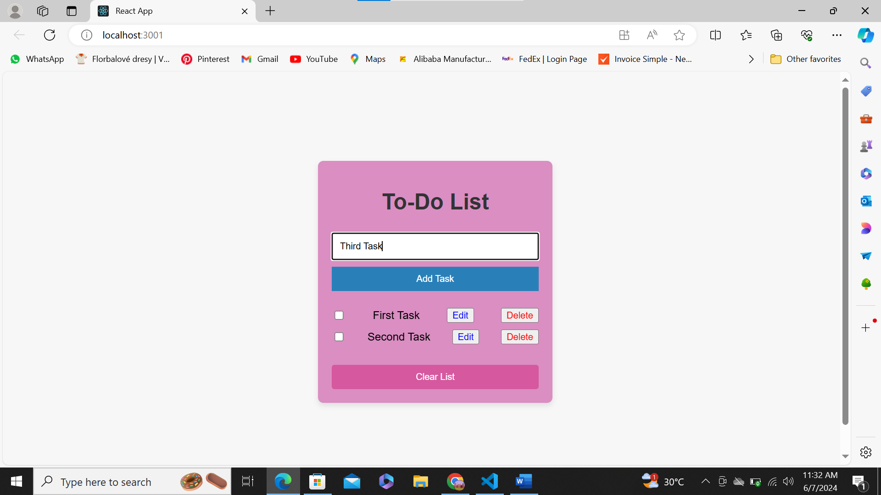

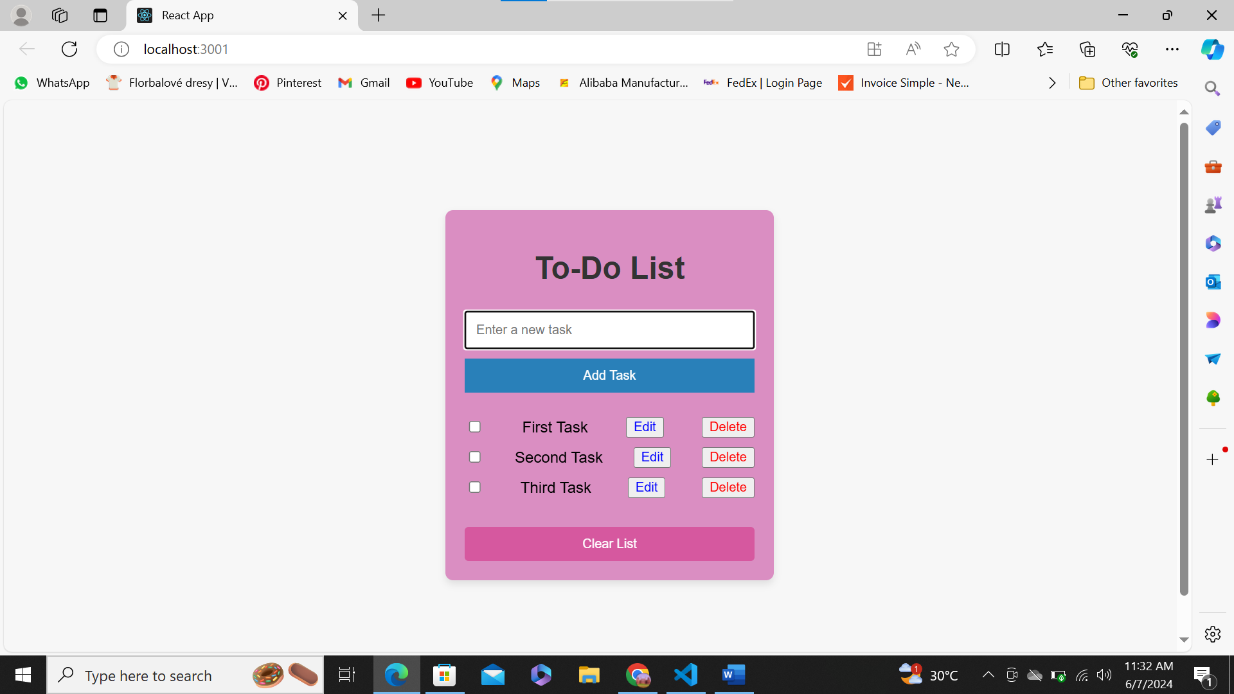

Add Three Task

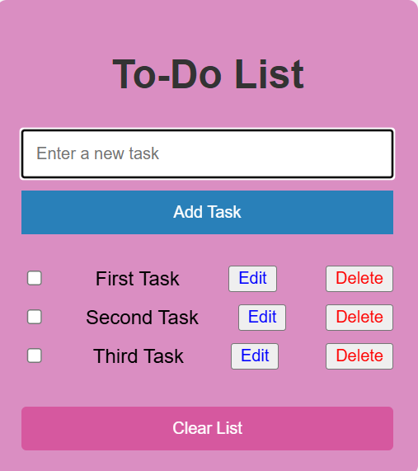

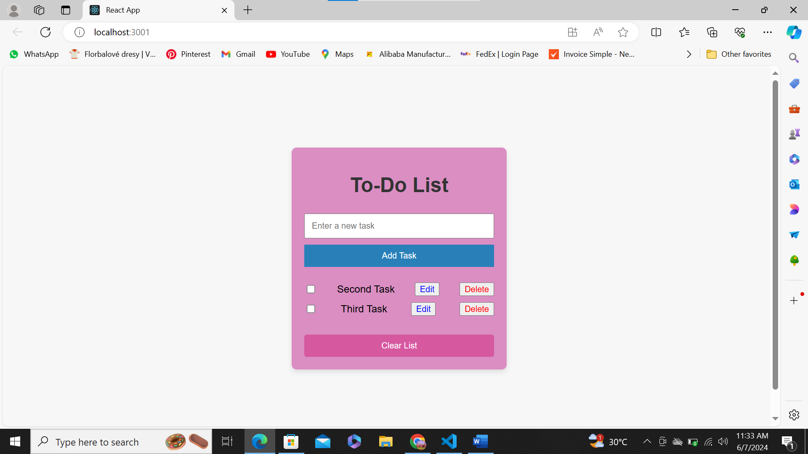

First Task deleted.

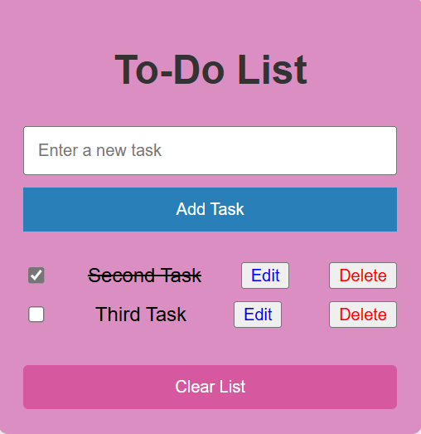

Checkboxes allow users to mark tasks as complete

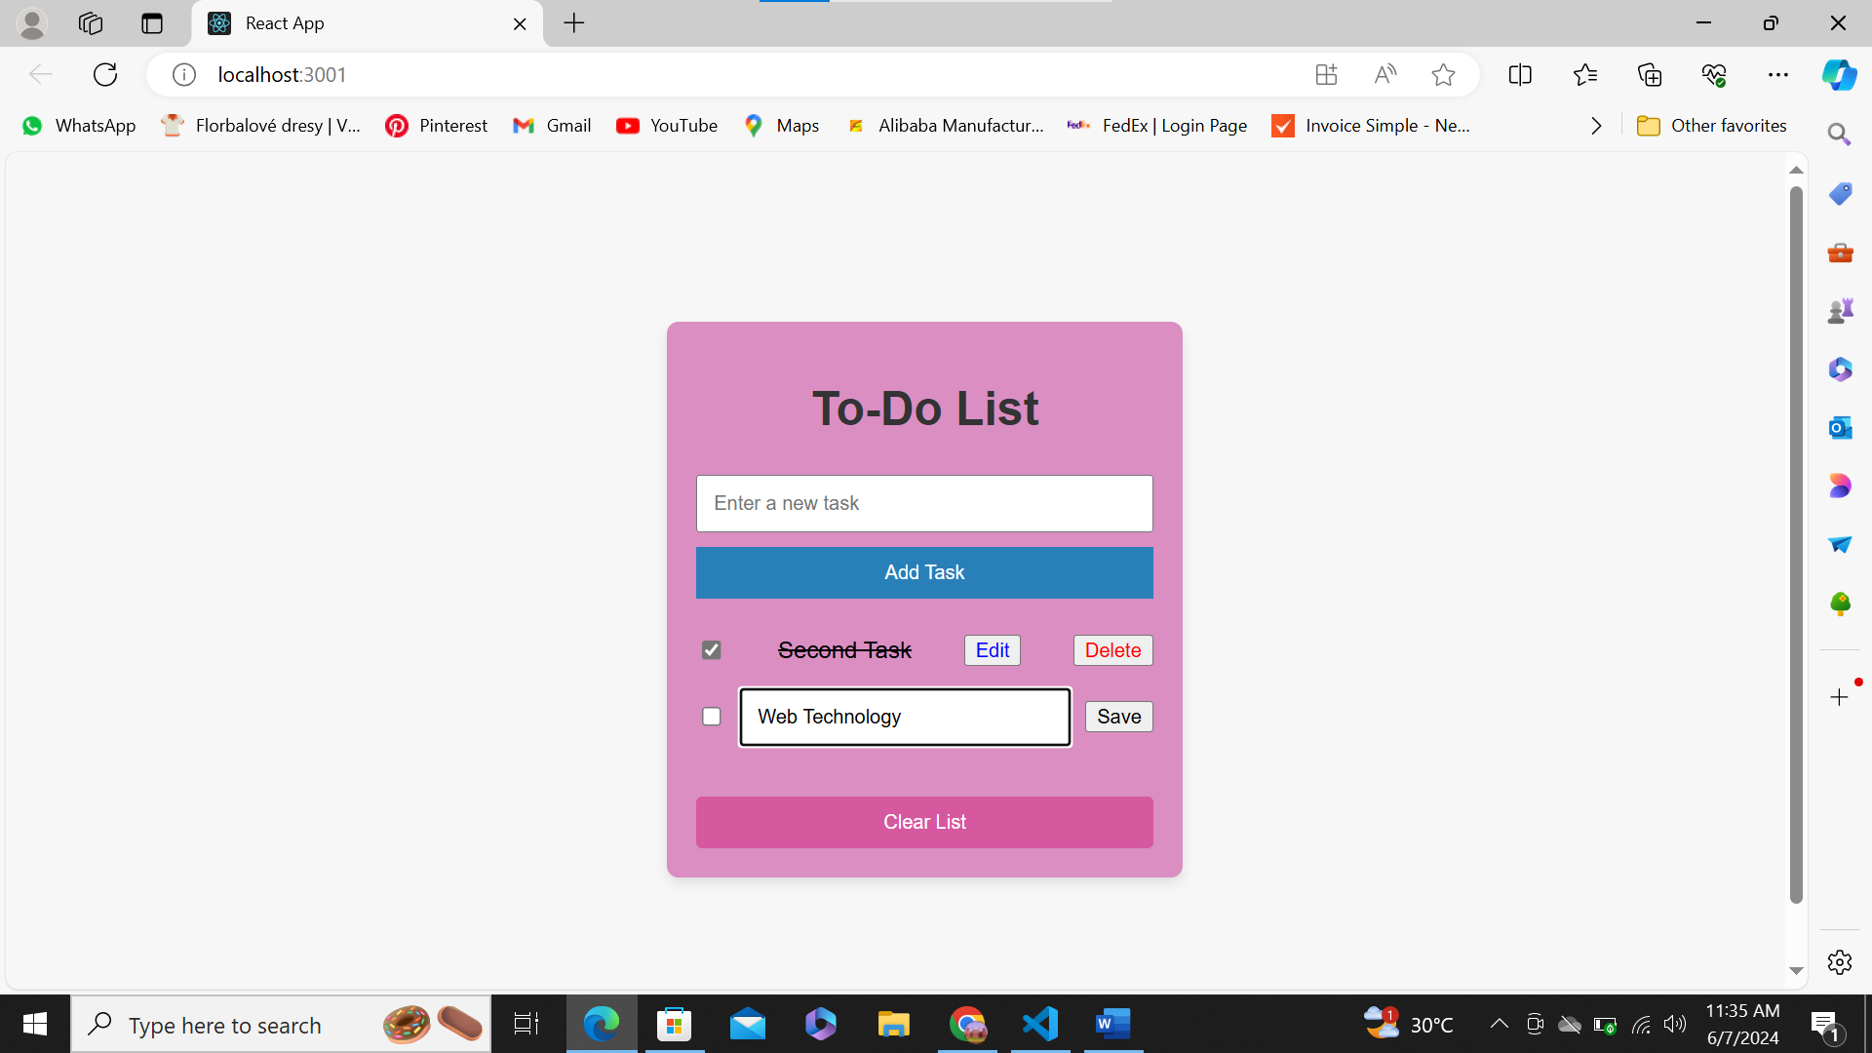

Edit the Third Task and save.

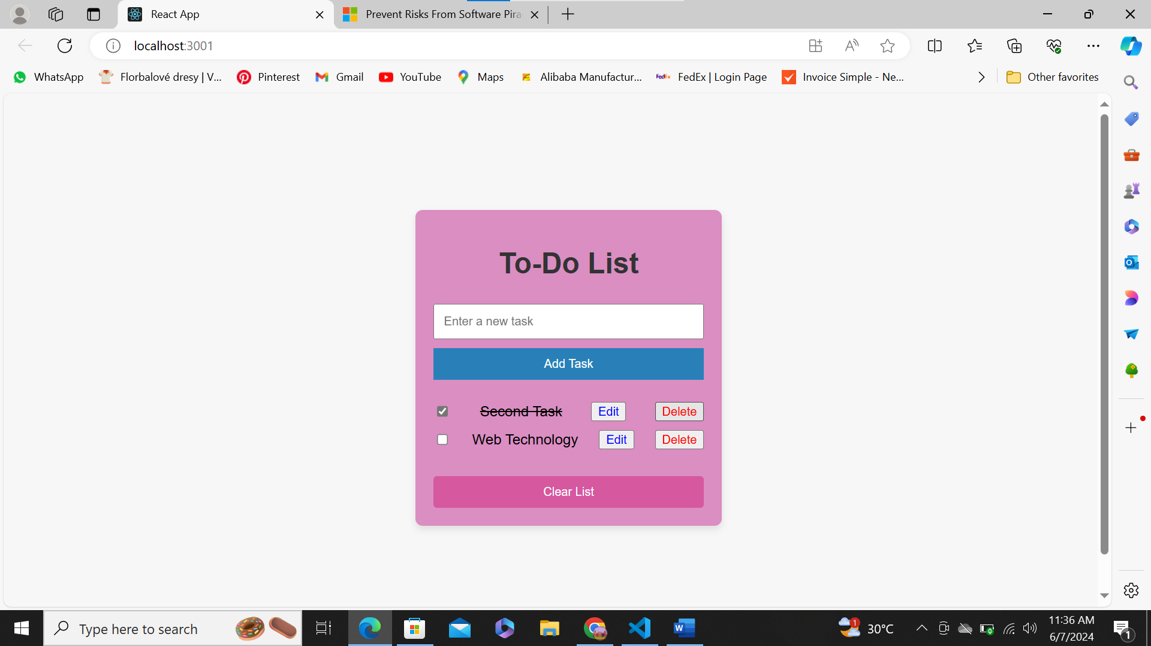

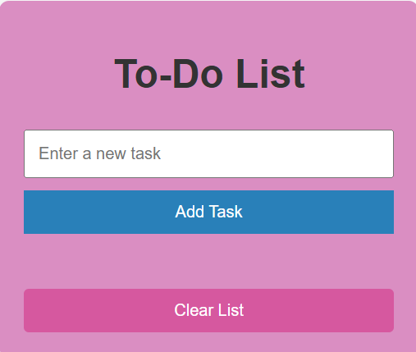

Clear List of All Task